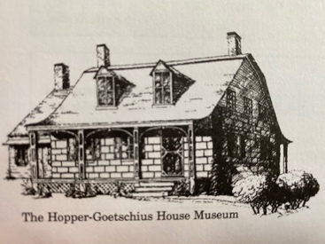
Upper Saddle River Historical Society

The mission of the Upper Saddle River Historical Society is
to collect, preserve and disseminate the history of the Upper Saddle River area,
and to administer the Hopper-Goetschius House Museum, outbuildings, and grounds.

The Upper Saddle River Historical Society invites all High School Students with an interest in local history, to apply for the position of:
Student Trustee
- Student Trustees are selected each year.
- Student Trustees will serve for up to four years (Freshman through Senior year of High School).
- Student Trustees are expected to attend 6 of our 9 monthly Board meetings which are held on the first Monday evening of the month at 7:00 pm during the school year and generally last an hour. Currently meetings are held in hybrid format––in-person downstairs at the Upper Saddle River Library (245 Lake Street) as well as on Zoom to accommodate all.
- Student Trustees are expected to volunteer for at least 16 hours over the course of each year––volunteering at 2 of our 4 museum events and 2 or more of our 2-4pm Summer Sundays, contributing at least 4 hours to an ongoing special project, and contributing 4 hours to various other needs of the Society and the museum such as Spring and Fall cleanups etc.

- Interested applicants must fill out the application form that follows on the next page and write a short statement explaining their interest in history, and what they feel they can contribute to the Historical Society.

- Student Trustees for any given year are chosen by the Historical Society’s Board of Trustees and notified prior to the next Board of Trustees meeting.

Questions? Email Trustee Nona Maher nona.maher@gmail.com
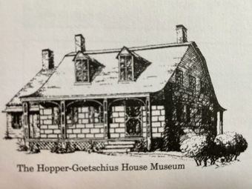
Upper Saddle River Historical Society

Student Trustee Application Form

The mission of the Upper Saddle River Historical Society is to collect, preserve and disseminate the history of the Upper Saddle River area, and to administer
The Hopper-Goetschius House Museum, outbuildings, and grounds.
Name______________________________________________________________
Address____________________________________________________________
High School_________________________________________________________
Current Grade/Graduation Year____________________________
Email (school and personal)____________________________________________
Cell Phone number___________________________________________________
Please attach your short statement of interest to this cover sheet. Do not put your name on the statement itself. Cover letters and statements will be numbered, and the cover sheet removed to ensure impartial selection of candidates.
Mail your application to:
Upper Saddle River Historical Society
c/o Maher
19 Midland Drive
Upper Saddle River, NJ 07458

Or scan and email it to nona.maher@gmail.com
Questions? Email Trustee Nona Maher

